2.1: a) During the later 4.75-s interval, the rocket moves a distance
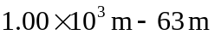, and so the magnitude of the average velocity is
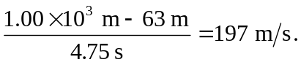
b) 